**Arduino-Based Computer Interface  
for the PN-2320 Pneumatic-Control Manual**

Prepared by:

Sinco, Micah Jude Kabristante

Villamor, Alfonzo Miguel Maxino

**HARDWARE**

*Plastic Tubing Connection*

1. Connect valve openings labeled with white circles to air pressure source as shown in figure 1.1.
2. Connect valve openings labeled with colors other than white, as shown in figure 1.1, to the actuator openings with the same color labeling as shown in figure 1.2.
3. Check if tubings as securely connected.

*Wiring Connection (Pneumatic-Control)*

1. Connect all positive inputs of all solenoid valves to the positive output of the 24V power supply.
2. Connect negative input of solenoid valve 1 labeled 1, as shown in figure 1.2, to the pin labeled 1 on the driver circuit as shown on figure 1.3 on the farthest right of the figure.
3. Do the same for the other three negative inputs labeled with numbers.
4. Connect ground pin of the driver circuit, as shown in figure 1.3 on the farthest right, to the ground input of the 24V power supply.
5. Connect micro-switches labeled with black and white boxes, as shown in figure 1.2, to the pins on the driver circuit with the same color labels as shown in figure 1.3.

*Wiring Connection (Arduino)*

1. Connect all pins labeled with voltage inputs, as shown in figure 1.3, to the respective voltage input pins on the arduino.
2. Connect all pins labeled with ground inputs, as shown in figure 1.3, to the ground input pins on the arduino.
3. Connect pin 2 and pin 3 on the driver circuit, as shown in figure 1.3, to the respective pins on the arduino with the same pin number.
4. Connect pins 8, 9, 10 and 11 on the driver circuit, as shown in figure 1.3, to the respective pins on the arduino with the same pin number.
5. Check for errors in the connection.

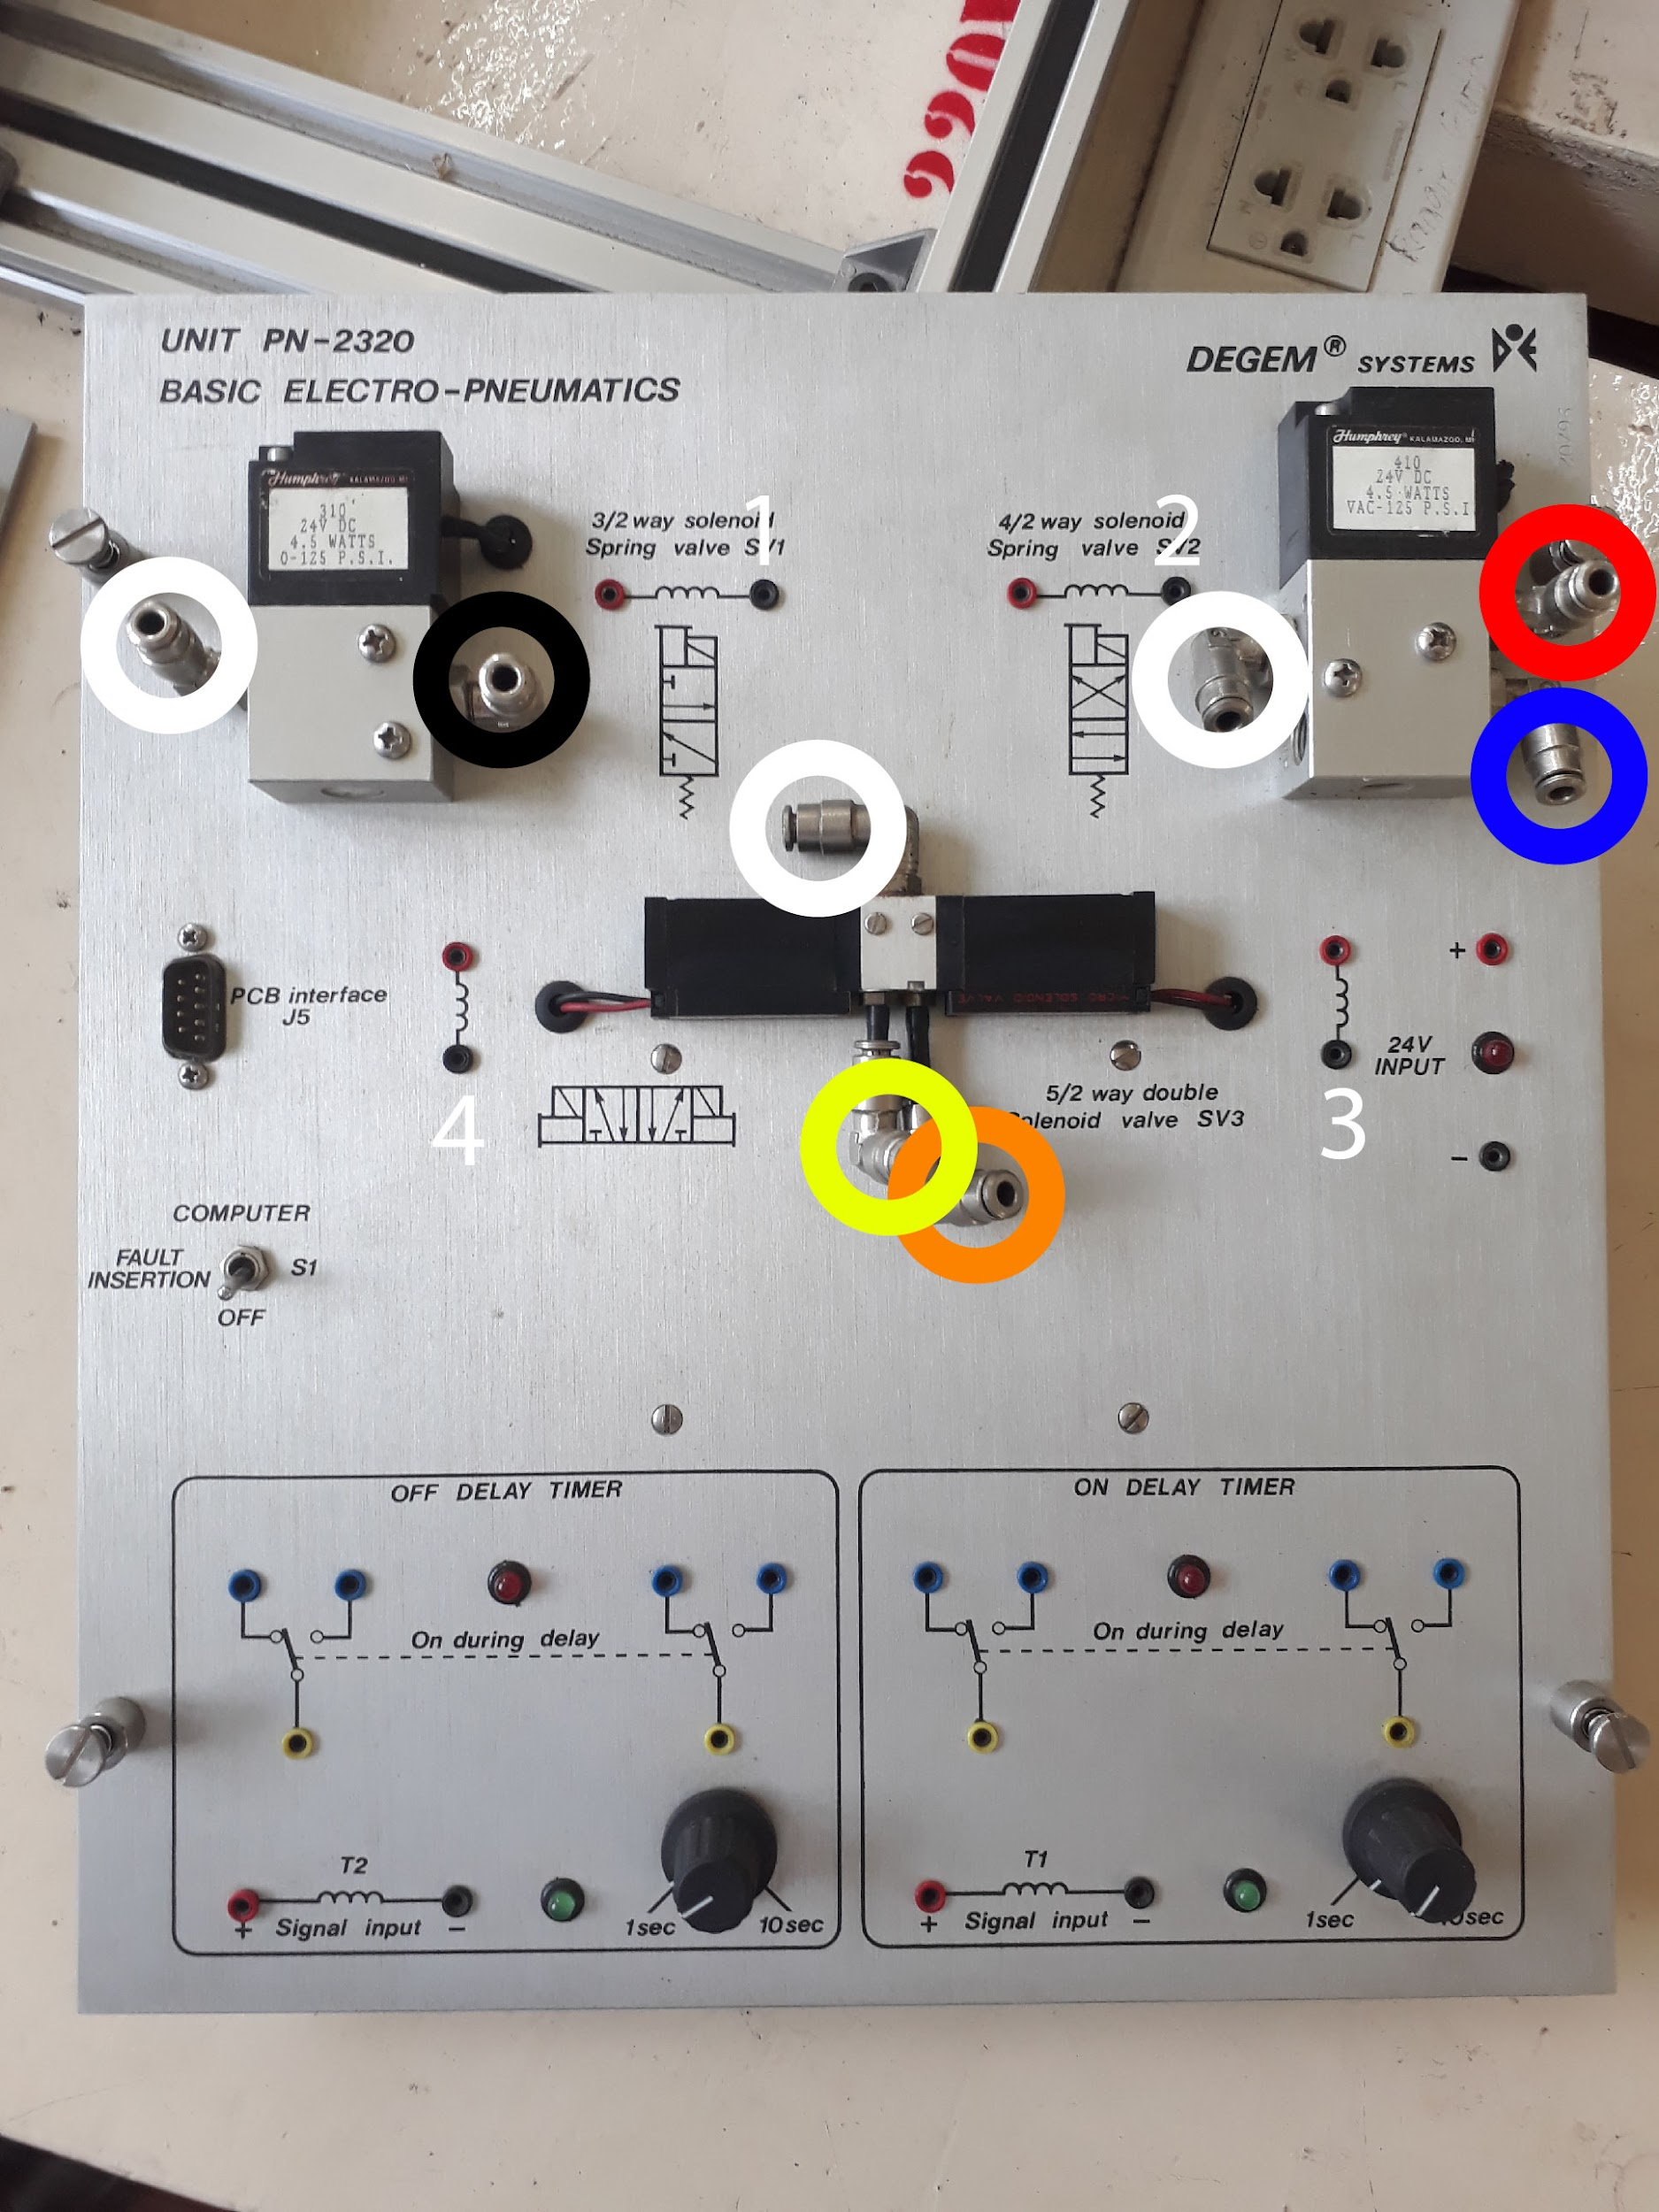

Figure 1.1

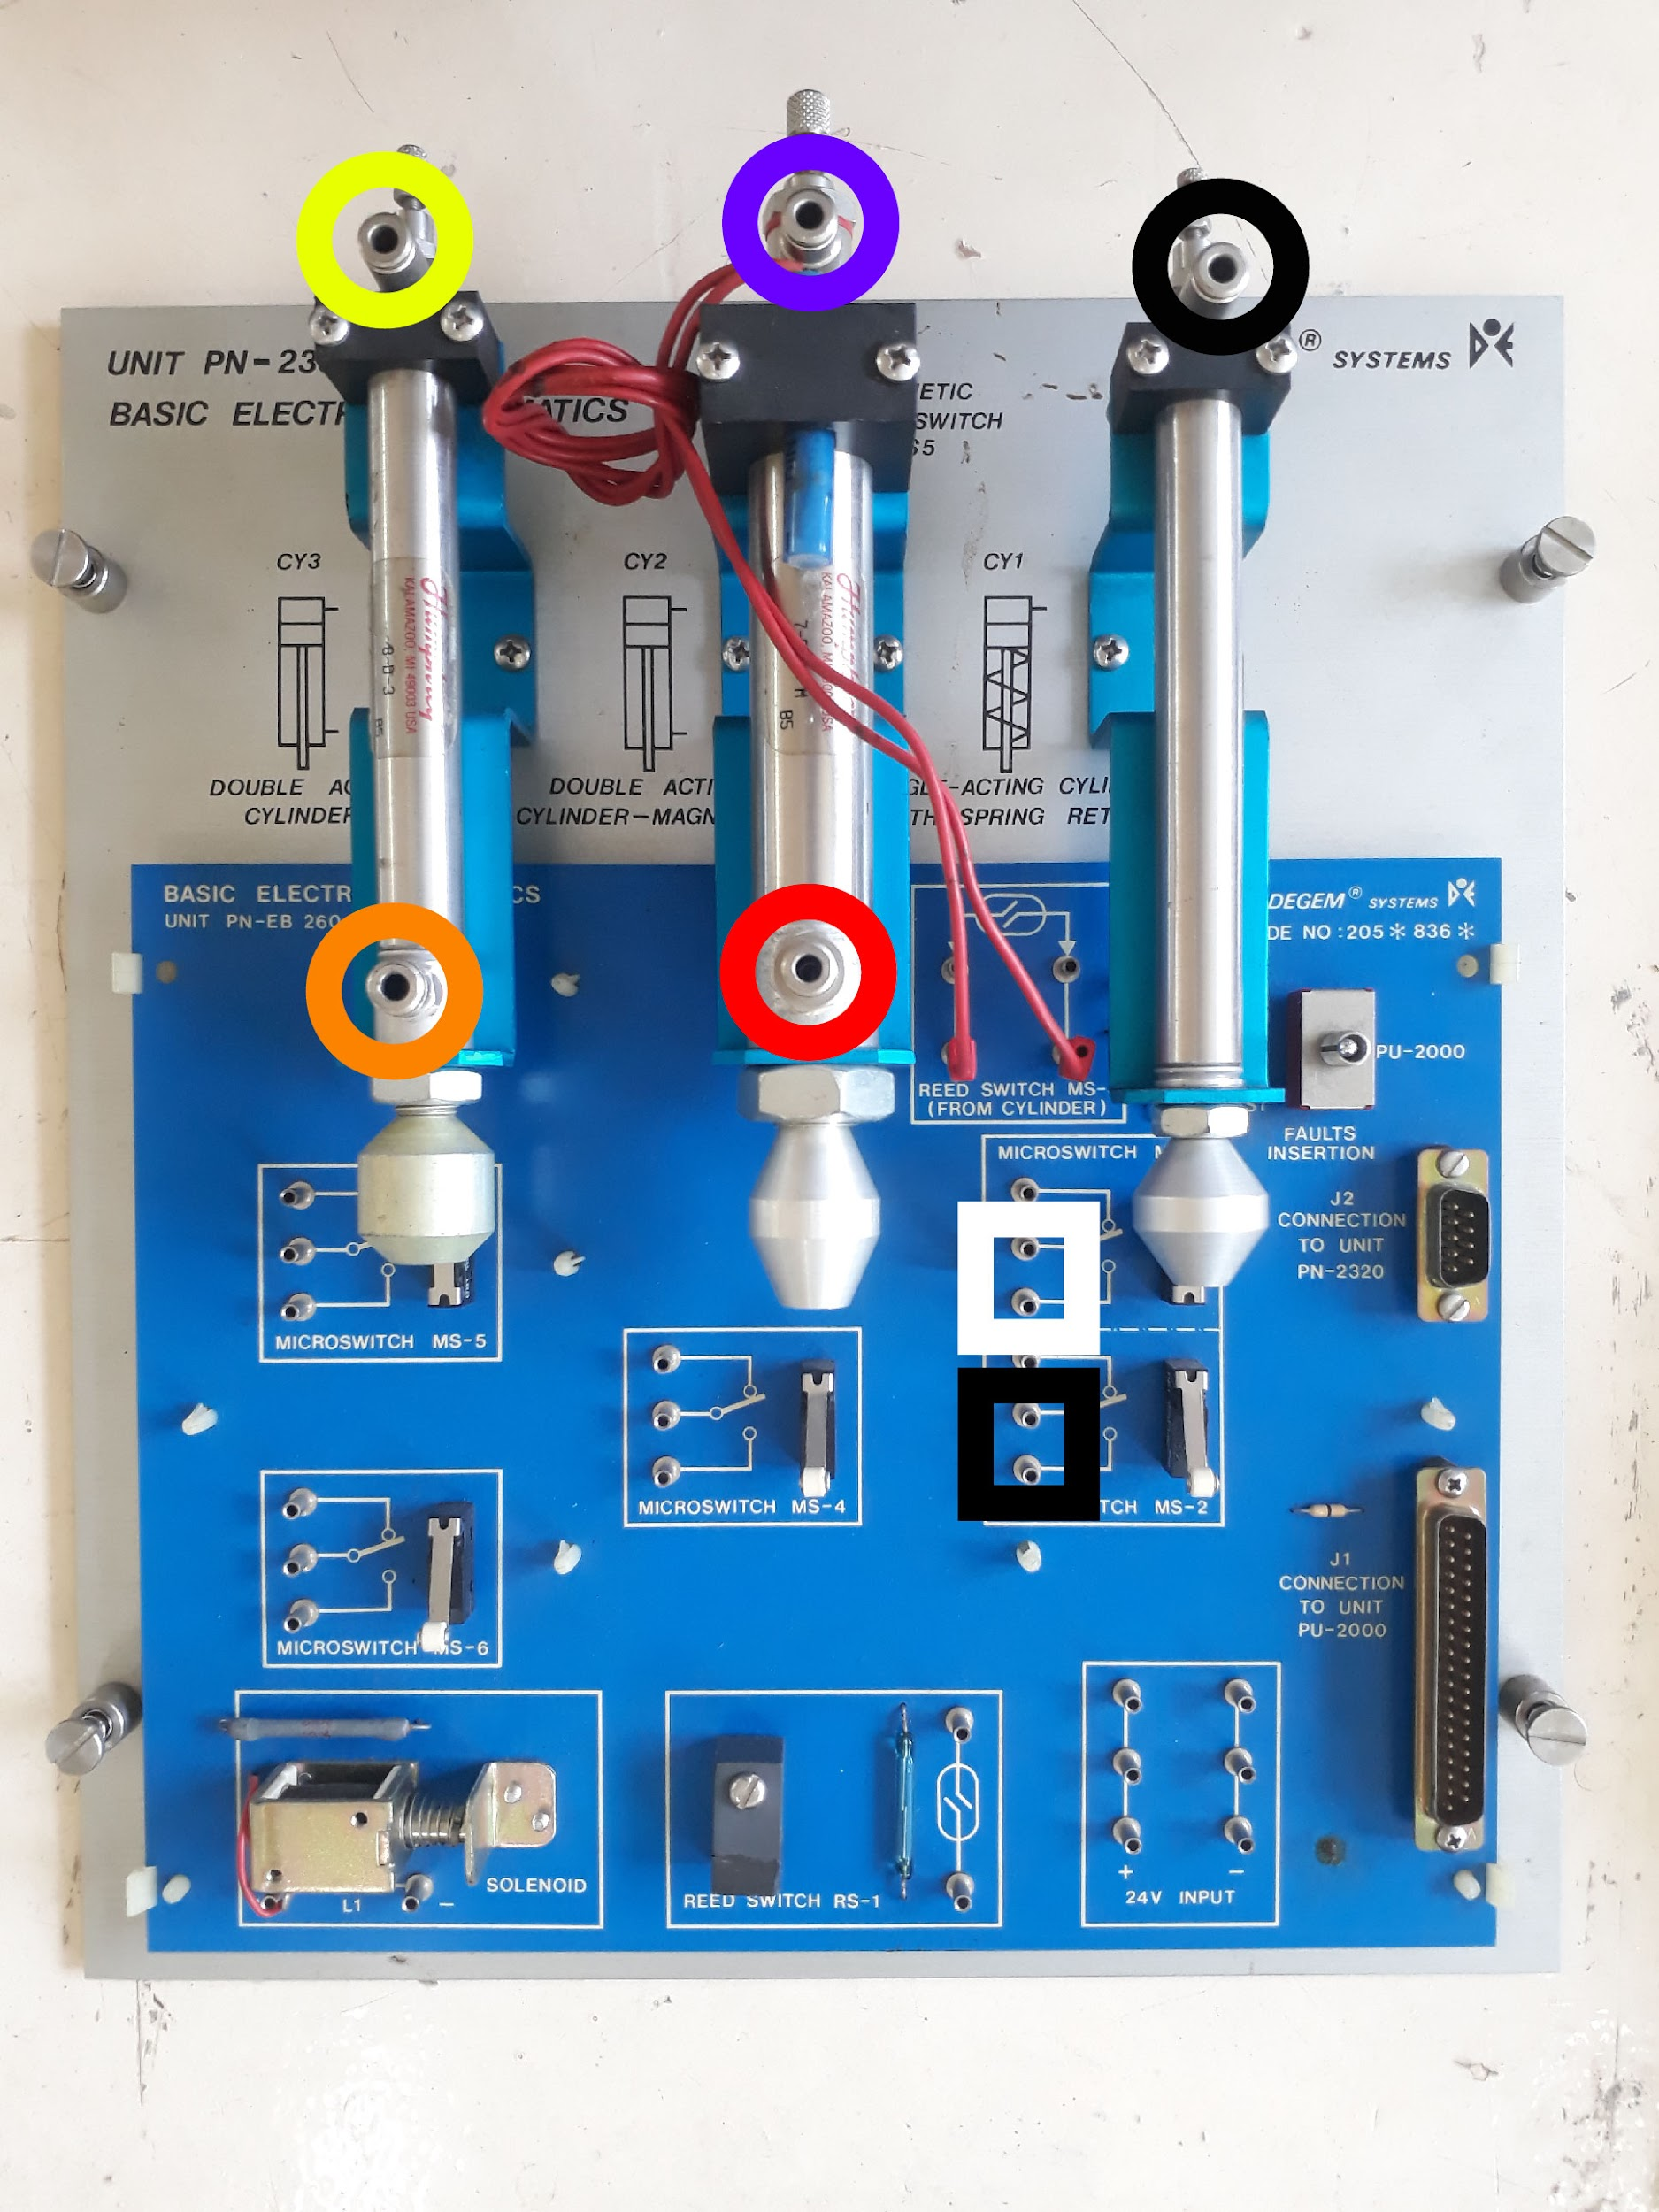

Figure 1.2

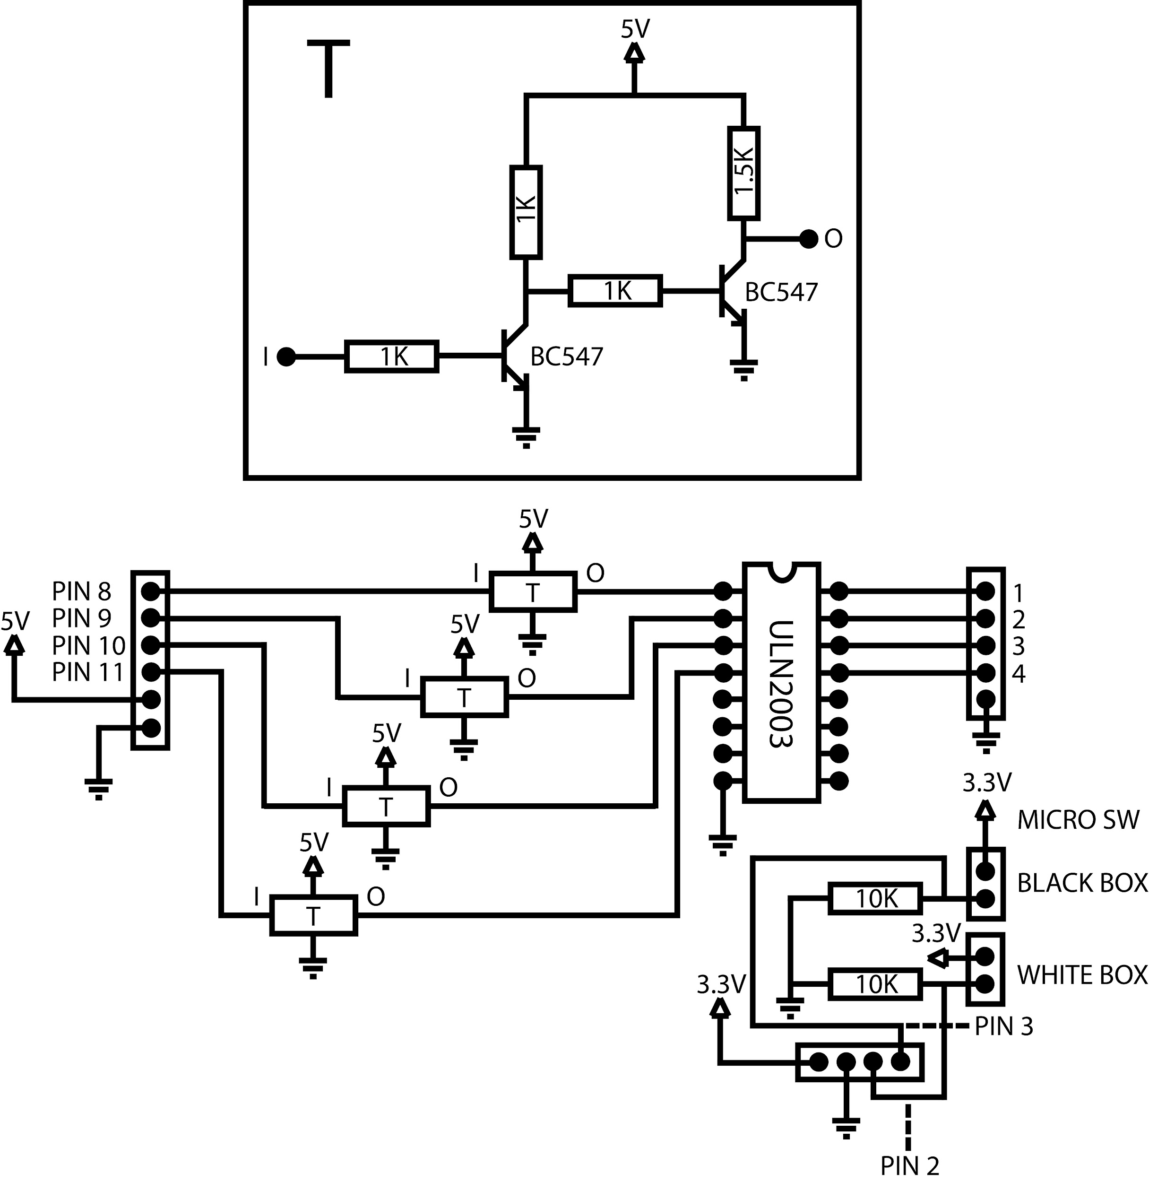

Figure 1.3

**USER INTERFACE**

Figure 2.1 shows the user interface for the application that controls the PN2320 Pneumatic Control. The UI has several functions: Direct Control Push Buttons, Direct Control Latch Buttons, Logic Circuit Simulation and Serial Editor. All functions will simply result to the switching on and off of solenoid valves.

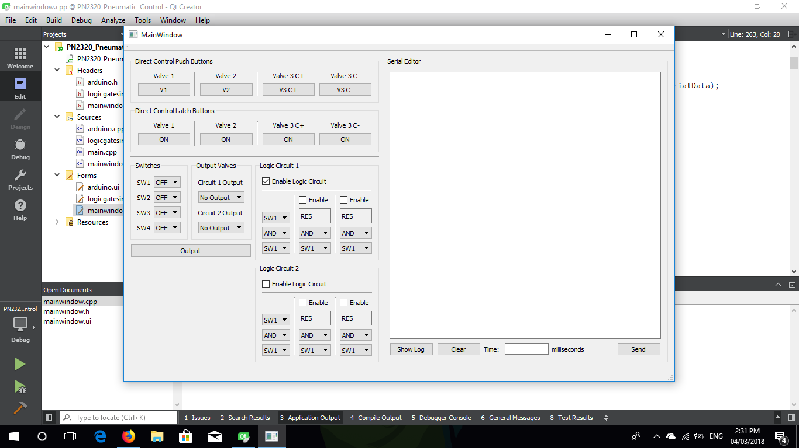

Figure 2.1

The Direct Control Push Buttons, as shown in figure 2.2, send signals to the microcontroller when the buttons are either pressed or released. When buttons are pressed, the application sends a keyword via serial to trigger the microcontroller to open the valve. On the other hand, the application sends a keyword to trigger the microcontroller to close the valve.

Pressed : valve opens

Released: valve closes

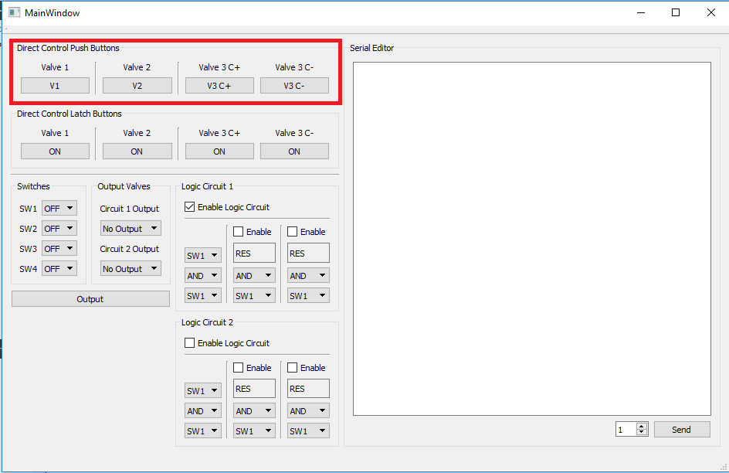

Figure 2.2

The Direct Control Latch Buttons, as shown in figure 2.3, operate similarly to the push buttons but has a slight difference. The buttons toggle ON or OFF when clicked or pressed.

Toggled ON: valve opens

Toggled OFF: valve closes

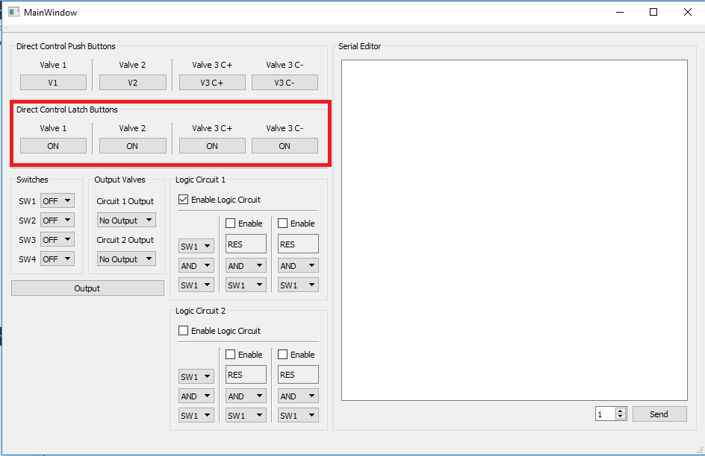

Figure 2.3

Figure 2.4 shows the Logic Circuit Simulation function of the application. The SWITCHES group contains four drop-down boxes that control the state of four switches. The OUTPUT VALVES group contains two drop-down boxes which lets the user select which valve to use as output for the two logic circuits. The LOGIC CIRCUIT groups contains several drop-down boxes and checkboxes that lets the application simulate a AND or OR connection.

Procedure:

1. Enable a logic circuit by checking the “Enable Logic Circuit” checkbox.
2. Enable 2nd or 3rd logic circuit connection if needed.
3. Set switches to simulate on Logic Circuit groupbox.
4. Set logic gate for simulation on Logic Circuit groupbox.
5. Set output valve for either circuit 1 or 2 on Output Valves groupbox.
6. Set switch states on Switches groupbox.
7. Click Output

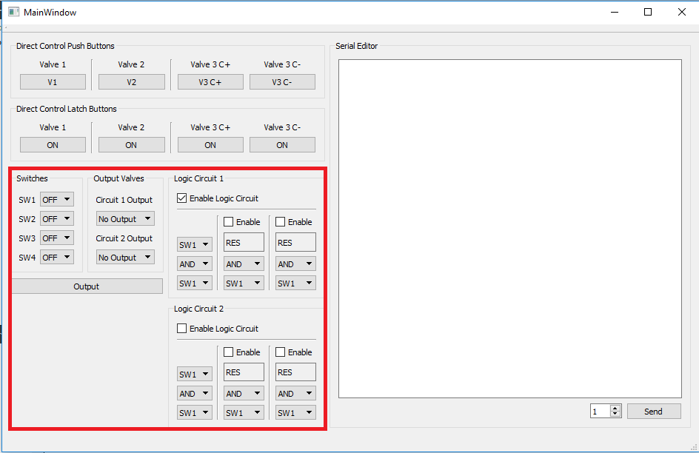

Figure 2.4

The Serial Editor, as shown in figure 2.5, allows the user to customly send instructions to the microcontroller via serial. Keywords are typed onto the text editor and are read and sent to the microcontroller when SEND button is clicked.

From the bottom left is the SHOW LOG button which displays the logged data for the duration of an actuator to reach from point A to point B. Next to it is the CLEAR button which clears the text editor. And lastly is the display box which shows the duration of an actuator to move from point A to point B in milliseconds.

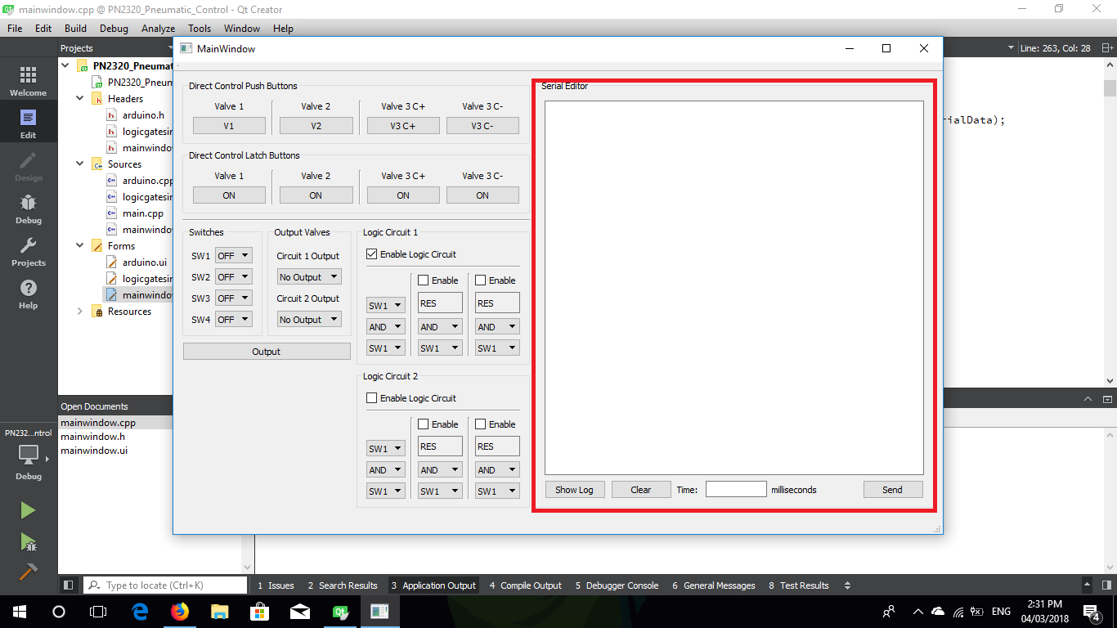

Figure 2.5